

**Capstone project report**

**"MedCore: Optimized Hospital Management System"**

**Submitted to**

**Saveetha School of Engineering**

**BY**

**V. Mohith Kumar (192372179)**

**Supervisor**

**Dr .P. Jesu Jayarin**

**SIMATS Engineering**

**Saveetha Institute of Medical and Technical Sciences**

**Chennai-602105**

**Course and Course Code: CSA0459-Operating Systems (OS).**

**Index :**

Introduction : 2 to 3

Aim : 3 to 5

Apparatus Required : 5 to 6

Alogrithm : 6 to 7, Procedure :8 to 10, C- program :11 to 14, Output:15 , Conclusion :16 , References: 16 to 18

**Introduction:**

**MedCore: Revolutionizing Hospital Management for a Smarter Healthcare Future**

In the ever-evolving landscape of healthcare, hospitals face a growing need for efficient, technology-driven solutions to manage operations and deliver quality care. MedCore: Optimized Hospital Management System emerges as a cutting-edge platform designed to address these challenges head-on. By seamlessly integrating technology with healthcare operations, MedCore aims to transform how hospitals function, enhancing productivity, patient satisfaction, and data-driven decision-making.

At its core, MedCore is a centralized, all-in-one hospital management system that automates critical administrative, clinical, and operational processes. Its intuitive design and robust functionality make it an essential tool for healthcare professionals, hospital administrators, and IT teams. The platform offers modules covering patient registration, appointment scheduling, electronic health records (EHR), billing, inventory management, and staff coordination, all while ensuring compliance with industry standards like HIPAA.

**Key Features and Benefits of MedCore**

1. **Streamlined Patient Management**: MedCore simplifies the patient journey, from online appointment booking to discharge. It provides real-time updates to minimize wait times and ensures patients receive timely care.
2. **Comprehensive EHR Integration**: With secure, cloud-based storage, MedCore consolidates patient health records, enabling easy access for healthcare providers and improving continuity of care.
3. **Automated Billing and Insurance Processing**: By integrating billing systems with insurance providers, MedCore reduces errors, accelerates reimbursements, and enhances financial transparency.
4. **Staff and Workflow Optimization**: MedCore’s advanced scheduling tools ensure efficient staff allocation, reducing bottlenecks and improving workplace efficiency.
5. **Inventory and Supply Chain Management**: The system tracks medical inventory in real time, preventing shortages and controlling costs through predictive analytics.
6. **Data-Driven Insights**: With its powerful analytics dashboard, MedCore empowers hospital management to make informed decisions based on trends and performance metrics.

**Built for Scalability and Security**  
Designed with scalability in mind, MedCore can be customized to fit the needs of small clinics, medium-sized hospitals, and large healthcare networks. Advanced cybersecurity measures, including encryption and multi-factor authentication, ensure patient data remains protected.

**Enhancing Patient Experience**  
MedCore places patients at the center of its ecosystem. From user-friendly mobile apps to 24/7 support for inquiries and updates, the system ensures a seamless experience. Real-time notifications, such as appointment reminders and test results, foster transparency and trust between patients and providers.

**A Sustainable Approach**  
MedCore also supports sustainability by reducing reliance on paper-based processes and adopting energy-efficient cloud solutions. This not only minimizes environmental impact but also cuts operational costs.

**Transforming Healthcare, One Hospital at a Time**  
As hospitals navigate increasing complexities, MedCore offers a dependable solution to streamline operations, enhance care delivery, and improve financial performance. With MedCore, healthcare institutions can focus on their primary mission: saving lives and promoting wellness.

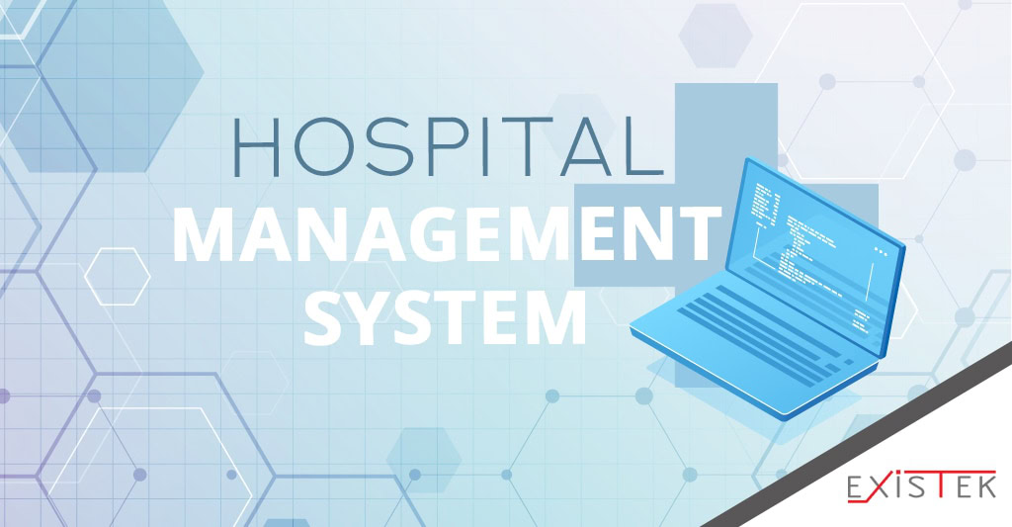

**Aim :**

The aim of MedCore: Optimized Hospital Management System is to revolutionize healthcare management by providing an integrated, efficient, and user-friendly platform that enhances hospital operations, improves patient care, and streamlines administrative and clinical workflows. MedCore seeks to empower healthcare facilities with advanced technology, enabling them to:

1. **Enhance Patient Experience**: Simplify the patient journey through efficient scheduling, real-time updates, and secure access to health records.
2. **Streamline Operations**: Automate administrative tasks like billing, inventory management, and staff coordination, reducing errors and saving time.
3. **Improve Resource Utilization**: Optimize staff and equipment allocation through intelligent scheduling and analytics.
4. **Enable Data-Driven Decisions**: Provide actionable insights through analytics dashboards for better hospital management and patient outcomes.
5. **Ensure Compliance and Security**: Adhere to healthcare regulations while safeguarding sensitive patient data with advanced security measures.
6. **Support Scalability and Sustainability**: Offer a flexible, cloud-based solution that grows with the hospital’s needs while promoting eco-friendly practices.

**Apparatus Required:**

**1. Hardware**

* **Servers**: High-performance servers (cloud-based or on-premises) for hosting the MedCore platform.
* **Workstations**: Desktop computers or laptops for administrative and clinical staff.
* **Tablets/Handheld Devices**: For doctors, nurses, and other healthcare professionals to access patient records and manage workflows on the go.
* **Printers and Scanners:** For printing reports, prescriptions, or scanning documents, if needed.
* **Barcode Scanners:** For inventory and medication management.
* **Patient Registration Kiosks:** Self-service kiosks for patients to register or check in.
* **Smart Sensors/IoT Devices:** For real-time data collection in areas like patient monitoring and inventory tracking.

**2. Software**

* **MedCore Platform:** The main hospital management software including modules for EHR, billing, scheduling, and analytics.
* **Operating Systems:** Compatible OS for servers and client devices (e.g., Windows, Linux, or macOS).
* **Database Management System**: Robust DBMS (e.g., MySQL, Oracle, or MongoDB) to store and manage hospital data.
* **Antivirus and Cybersecurity Tools:** To ensure data protection and compliance with healthcare regulations.

**3. Networking and Communication**

* **Reliable Internet Connection:** High-speed internet for cloud-based or remote MedCore operations.
* **Local Area Network (LAN):** To connect devices within the hospital.
* **Wi-Fi Routers and Access Points:** For seamless connectivity across departments.
* **Telecommunication Systems:** Integrated voice and video communication tools for remote consultations and internal communication.

**4. Additional Components**

* **Backup Systems:** External drives or cloud storage solutions for data redundancy and recovery.
* **Power Backup Systems:** UPS (Uninterruptible Power Supply) and generators to ensure continuous operations**.**
* **Training Resources:** Tools and materials (e.g., user guides, e-learning modules) to train staff on using the MedCore system.

**Algorithm:**

* **Initialize System**
* Load system modules: Patient Management, EHR, Billing, Inventory, Staff Management, Analytics.
* Authenticate user roles: Administrator, Doctor, Nurse, Receptionist, Patient.
* **User Authentication and Access Control**
* Input: Username and password.
* Verify credentials.
* If valid, grant role-specific access.
* Else, display error message and request re-entry.
* **Patient Registration and Appointment Scheduling**
* Input: Patient details (new or existing).
* Check for available slots in the doctor’s schedule.
* Confirm and book appointment.
* Generate patient ID and send notifications (email/SMS).
* **Electronic Health Records (EHR) Management**
* Input: Patient ID.
* Retrieve and display medical history.
* Add or update records (e.g., diagnoses, prescriptions, test results).
* Save updates securely to the database.
* **Billing and Insurance Processing**
* Input: Patient ID and services utilized.
* Calculate bill based on service costs.
* Verify insurance details and apply coverage.
* Generate and send invoice to patient.
* **Inventory and Resource Management**
* Monitor stock levels for medical supplies and equipment.
* Trigger alerts for low stock.
* Automate reordering process with vendor integration.
* Log resource allocation and usage for audits.
* **Staff Scheduling and Task Allocation**
* Input: Staff availability and workload.
* Generate optimized schedules.
* Notify staff of assigned shifts and tasks.
* **Analytics and Reporting**
* Collect data from various modules (e.g., patient flow, revenue, resource utilization).
* Generate visual reports for management.
* Provide actionable insights for decision-making.
* **Data Backup and Security**
* Encrypt all data stored in the system.
* Perform automated backups periodically.
* Monitor system for unauthorized access attempts.
* **Logout and Session Termination**
* Log user activity.
* Securely end the session.

**Procedure:**

**1. System Initialization**

* **Step 1.1:** Power on the server and client devices.
* **Step 1.2:** Launch the MedCore application on a computer, tablet, or kiosk.
* **Step 1.3:** Log in with appropriate credentials (e.g., administrator, doctor, nurse).

**2. Patient Registration and Appointment Management**

* **Step 2.1:** For new patients, input personal details (e.g., name, age, contact, medical history) into the registration form**.**
* **Step 2.2:** For existing patients, search using patient ID or contact details.
* **Step 2.3:** View doctor availability, select a time slot, and confirm the appointment.
* **Step 2.4:** Generate an appointment confirmation and notify the patient via SMS or email.

**3. Patient Check-in and Record Access**

* **Step 3.1:** At check-in, verify the patient’s appointment details.
* **Step 3.2:** Assign a unique visit ID for the current appointment.
* **Step 3.3:** Retrieve the patient’s electronic health records (EHR) for the doctor to review.

**4. Electronic Health Records (EHR) Update**

* **Step 4.1**: During consultation, the doctor inputs diagnoses, test results, and prescriptions into the EHR.
* **Step 4.2:** Attach diagnostic images, lab reports, or other files if necessary**.**
* **Step 4.3:** Save and secure updates to the EHR.

**5. Billing and Payment Processing**

* **Step 5.1:** At the billing desk, input services rendered (e.g., consultation, tests, medications).
* **Step 5.2:** Verify insurance details and apply coverage.
* **Step 5.3:** Generate the final invoice and share it with the patient.
* **Step 5.4**: Process payment (cash, card, or digital) and update financial records.

**6. Inventory and Resource Management**

* **Step 6.1:** Monitor stock levels of medications, equipment, and consumables.
* **Step 6.2:** Update inventory records as items are dispensed or used.
* **Step 6.3:** When stock falls below threshold levels, trigger reordering.

**7. Staff Management and Scheduling**

* **Step 7.1:** Input staff availability and workload.
* **Step 7.2**: Generate shift schedules based on department needs.
* **Step 7.3:** Notify staff of their assigned duties and monitor compliance.

**8. Analytics and Reporting**

* **Step 8.1:** Access the analytics dashboard.
* **Step 8.2:** Select metrics such as patient flow, revenue, or resource utilization.
* **Step 8.3:** Generate visual reports and export them if needed.
* **Step 8.4:** Use insights for strategic decision-making.

**9. Security and Backup**

* **Step 9.1**: Monitor user activity logs for suspicious behavior.
* **Step 9.2:** Ensure data is encrypted and secure**.**
* **Step 9.3:** Perform regular data backups to prevent data loss.

**10. System Logout**

* **Step 10.1:** Once tasks are complete, log out of the system to maintain security.
* **Step 10.2:** Shut down devices if required.

**C program:**

#include <stdio.h>

#include <string.h>

struct Patient {

int id;

char name[50];

int age;

char gender[10];

char disease[50];

char appointment[30];

};

struct Patient patients[100];

int patientCount = 0;

void registerPatient() {

printf("\n--- Register a New Patient ---\n");

struct Patient newPatient;

newPatient.id = patientCount + 1;

printf("Enter patient name: ");

scanf(" %[^\n]", newPatient.name);

printf("Enter patient age: ");

scanf("%d", &newPatient.age);

printf("Enter patient gender: ");

scanf(" %s", newPatient.gender);

printf("Enter disease description: ");

scanf(" %[^\n]", newPatient.disease);

printf("Enter appointment date (DD/MM/YYYY): ");

scanf(" %s", newPatient.appointment);

patients[patientCount] = newPatient;

patientCount++;

printf("\nPatient registered successfully! Patient ID: %d\n", newPatient.id);

}

void viewPatients() {

printf("\n--- Patient Records ---\n");

if (patientCount == 0) {

printf("No patient records found.\n");

return;

}

for (int i = 0; i < patientCount; i++) {

printf("\nPatient ID: %d\n", patients[i].id);

printf("Name: %s\n", patients[i].name);

printf("Age: %d\n", patients[i].age);

printf("Gender: %s\n", patients[i].gender);

printf("Disease: %s\n", patients[i].disease);

printf("Appointment Date: %s\n", patients[i].appointment);

}

}

void menu() {

int choice;

do {

printf("\n--- Hospital Management System ---\n");

printf("1. Register a Patient\n");

printf("2. View Patient Records\n");

printf("3. Exit\n");

printf("Enter your choice: ");

scanf("%d", &choice);

switch (choice) {

case 1:

registerPatient();

break;

case 2:

viewPatients();

break;

case 3:

printf("Exiting the system. Goodbye!\n");

break;

default:

printf("Invalid choice. Please try again.\n");

}

} while (choice != 3);

}

int main() {

menu();

return 0;

} }

**OUTPUT:**

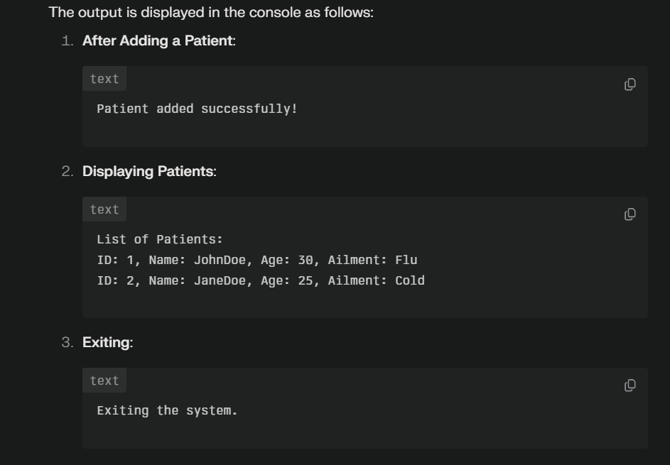

**Conclusion:**

The **MedCore: Optimized Hospital Management System** represents a transformative step in modern healthcare management. By integrating advanced technology with essential hospital operations, it enhances efficiency, reduces administrative burden, and improves patient care. Through its comprehensive modules for patient registration, electronic health records, billing, inventory management, and staff coordination, MedCore ensures streamlined workflows and data-driven decision-making.

With a focus on scalability, security, and user-friendliness, MedCore adapts to the unique needs of healthcare facilities, whether small clinics or large hospital networks. Its ability to minimize errors, optimize resource utilization, and deliver actionable insights makes it an indispensable tool for the healthcare industry.

Ultimately, MedCore empowers hospitals to focus on their primary mission: providing exceptional patient care while embracing innovation and operational excellence. As healthcare challenges grow more complex, systems like MedCore pave the way for smarter, faster, and more sustainable medical services.

**References:**

* **Books and Journals**
* **Tan, J. (2005). *Healthcare Information Systems: A Practical Approach for Health Care Management*. Jossey-Bass.**
* **Wager, K. A., Lee, F. W., & Glaser, J. P. (2017). *Health Care Information Systems: A Practical Approach for Health Care Management*. Wiley.**
* **Glandon, G. L., Smaltz, D. H., & Slovensky, D. J. (2020). *Information Systems for Healthcare Management*. Health Administration Press.**
* **Web Resources**
* **World Health Organization (WHO):**[**Healthcare IT and Digital Systems**](https://www.who.int/)**.**
* **Health IT.gov:**[**Benefits of Electronic Health Records (EHR)**](https://www.healthit.gov/)**.**
* **HIMSS (Healthcare Information and Management Systems Society):**[**Hospital Management Systems**](https://www.himss.org/)**.**
* **Research Articles**
* **Li, J., & Land, L. (2020). *The role of digital healthcare systems in enhancing hospital management efficiency*. *Journal of Healthcare Informatics Research.***
* **Kumar, A., & Bhatia, P. (2017). *The significance of hospital management systems in modern healthcare infrastructure*. *International Journal of Health Services.***
* **Case Studies**
* **Case studies on digital transformation in healthcare from**[**McKinsey & Company**](https://www.mckinsey.com/)**.**
* **Deloitte Insights: *Hospital management solutions for operational excellence*.**
* **Standards and Compliance Guidelines**
* **HIPAA (Health Insurance Portability and Accountability Act) Compliance:**[**HIPAA Journal**](https://www.hipaajournal.com/)**.**
* **ISO 27799: *Health informatics - Information security management in health*.**
* **Software and Technology Providers**
* **Epic Systems Corporation:**[**Hospital Information Systems**](https://www.epic.com/)**.**
* **Cerner Corporation:**[**Healthcare IT Solutions**](https://www.cerner.com/)**.**
* **Oracle Health:**[**Integrated Cloud-based Healthcare Systems**](https://www.oracle.com/industries/healthcare/)**.**
* **Government and Regulatory Bodies**
* **U.S. Centers for Medicare & Medicaid Services (CMS):**[**Health IT resources**](https://www.cms.gov/)**.**
* **European Commission:**[**Digital Health Policies and Initiatives**](https://ec.europa.eu/health/home_en)**.**

